TASK#1:

#include <iostream>
#include <string>
using namespace std;

struct employee
{

int emp_num;
float emp_com;
};

int main()
{
employee emp[3];
for (int i = 0; i < 3; i++)
{
cout << "Enter the employee number:" << endl;
cin >> emp[i].emp_num;
cout << "Enter the employee compensation :" << endl;
cin >> emp[i].emp_com;
}

cout << "...........................DETAILS........................... " << endl;
for (int i = 0; i < 3; i++)
{
cout << "Number:" << emp[i].emp_num << endl;

cout << "Compensation:"
<< "$" << emp[i].emp_com << endl;
}
return 0;
}

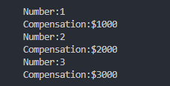
TASK#2:

#include <iostream>
#include <string>
using namespace std;

struct time
{
int hours;
int minutes;
int seconds;
};

int main()
{
time numb;
int total_seconds;
cout << "Enter the Hours" << endl;
cin >> numb.hours;
cout << "Enter the Minutes" << endl;
cin >> numb.minutes;
cout << "Enter the Seconds" << endl;
cin >> numb.seconds;

cout << "Hours:" << numb.hours << " "
<< "Minutes:" << numb.minutes << " "
<< "Seconds:" << numb.seconds << endl;
total_seconds = numb.hours * 3600 + numb.minutes * 60 + numb.seconds;
cout << "and total seconds are:"
<< " " << total_seconds << "sec" << endl;
return 0;
}

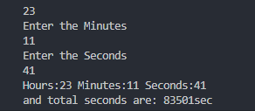
TASK#3:

#include <iostream>
#include <string>
using namespace std;

struct time
{
int hours;
int minutes;
int seconds;
};

int main()
{
time numb, numb1;
int total_seconds, minutes, seconds, hours;
cout << "Enter the Hours" << endl;
cin >> numb.hours;
cout << "Enter the Minutes" << endl;
cin >> numb.minutes;
cout << "Enter the Seconds" << endl;
cin >> numb.seconds;

total_seconds = numb.hours * 3600 + numb.minutes * 60 + numb.seconds;
cout << "and total seconds of 1st time is :"
<< " " << total_seconds << "sec" << endl;

cout << "Enter the 2nd Hours" << endl;
cin >> numb1.hours;
cout << "Enter the 2nd Minutes" << endl;
cin >> numb1.minutes;
cout << "Enter the 2nd Seconds" << endl;
cin >> numb1.seconds;
total_seconds = numb1.hours * 3600 + numb1.minutes * 60 + numb1.seconds;
cout << "and total seconds 2nd time is:"
<< " " << total_seconds << "sec" << endl;

seconds = numb.seconds + numb1.seconds;
minutes = numb.minutes + numb1.minutes + (seconds / 60);
hours = numb.hours + numb1.hours + (minutes / 60);

cout << "Total time is:" << hours << ":" << minutes << ":" << seconds << endl;

return 0;
}

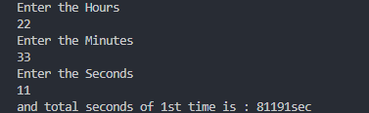

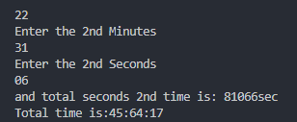

TASK#4:

#include <iostream>
#include <string>
using namespace std;

struct volume
{
int length, width, height, l_inch, w_inch, h_inch;
};

int main()
{
volume v;
cout << "....First of all enter feet then inches...." << endl;
cout << "Enter the length of room in feet and inches : ";
cin >> v.length >> v.l_inch;
cout << "Enter the width of room in feet and inches : ";
cin >> v.width >> v.w_inch;
cout << "Enter the Height of room in feet and inches : ";
cin >> v.height >> v.h_inch;

float length, width, height, volume;
length = v.length + ((float)(v.l_inch) / 12);
width = v.width + ((float)(v.w_inch) / 12);
height = v.height + ((float)(v.h_inch) / 12);
cout << "The length of room in foot is : " << length << endl;
cout << "The width of room in feet is: " << width << endl;
cout << "The Height of room in feet is : " << height << endl;
volume = length * width * height;
cout << "Volume of the room is: " << volume;

return 0;
}
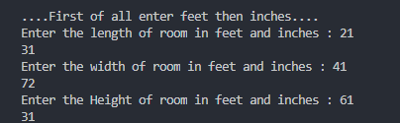
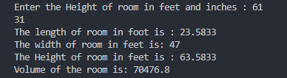

TASK#5:

#include <iostream>
#include <string>
using namespace std;

struct phone
{
int area_code, exchange_code, number;
};

int main()
{
phone numb;
cout << "Enter your area code number:" << endl;
cin >> numb.area_code;
cout << "Enter your exchange code number:" << endl;
cin >> numb.exchange_code;
cout << "Enter your phone number:" << endl;
cin >> numb.number;
cout << "Your number is:"
<< "(" << numb.area_code << ")"
<< "-" << numb.exchange_code << "-" << numb.number << endl;

return 0;
}

